**Flow Chart**

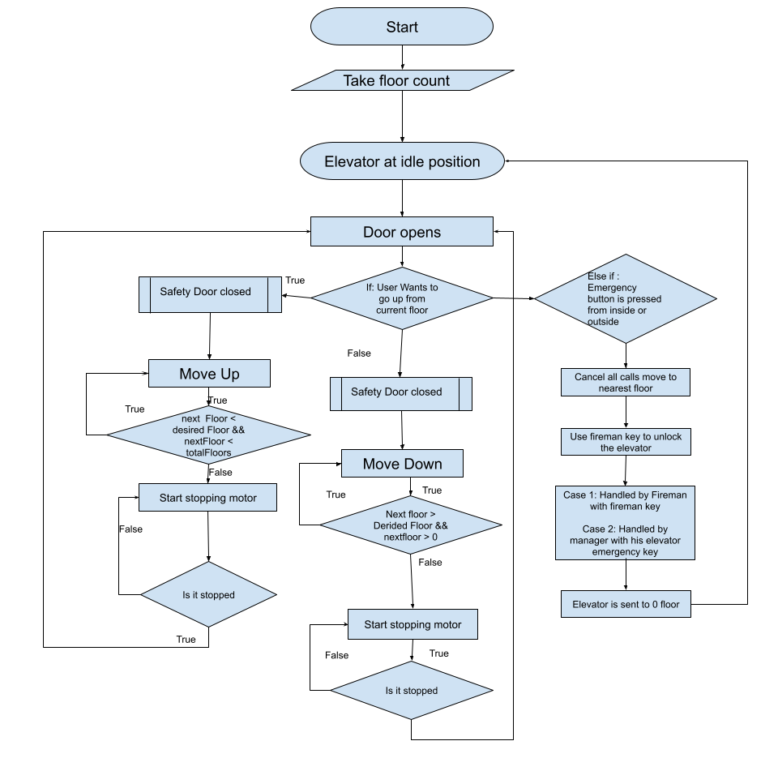

**Pseudo Code of elevator working**

**Step** 1 - Start

**Step** 2 - Get the input from the user, total number of floors

**Step** 3 - Get the user input to move to the floor

**Step** 4 -If the user wants to go to floor greater than the current floor then the elevator will start going upwards

**ELSE IF** If user wants to go to floor lesser than the current floor then the elevator will start going downwards

**Step 5** If the desired floor is equal to the current floor then the door is opened and continues with the next input of the user

**Step 6** If the emergency key is pressed then all the operators are halted and the elevator moves to the next floor for safety evacuation.

Step 7 After the emergency key, either the fireman can unlock the elevator or the manager

In this program, elevator working is demonstrated. This will start with the floors count of the elevator and it is considered that initially the elevator is at 0 floor. When the user opens the elevator to use it, its input is required to help to determine whether the elevator will move in an upwards or downwards direction. As the elevator is currently at 0 floor then it will move to the floor selected by the user floor by floor. When the desired floor arrives, the motor of the elevator is stopped and the elevator doors are opened.

For example:

* There are 6 floors in the building
* Initially, elevator is at position 0, ground floor
* User from 3rd floor presses the button of elevator
* Elevator elevates to 1 floor and checks the condition of the user floor. If not then the elevator continues till the floor is reached.
* When the third floor arrives, the elevator door opens and the user enters the elevator and presses the button on the floor where he wants to go. In this case the user presses 5.
* Then the elevator door will close and the elevator moves upwards till the desired floor reaches.
* Someone pressed the elevator button from outside from floor 2. In this case the elevator will not move downwards till the first work is completed. After completing the first work it will follow the second command to go downwards.
* In the case of any emergency, an emergency key is pressed, either from inside of the elevator or from outside. In both cases, the elevator stops at the next floor for safe evacuation of users. After this only the fireman or the manager can reset the lift and after resetting, it moves to its initial position.